SIMATS ENGINEERING

SAVEETHA INSTITUTE OF MEDICAL AND TECHNICAL SCIENCES
CHENNAI – 602105

Department of Computer Science and Engineering

ASSESSMENT TOOL 3 – OPEN DATA ANALYSIS PROJECT

Course Code: | DSA05 | Course Title: | Query Processing for Data Science in Real Time Applications
CO Assessed: | CO4 | Assessment: | Tool 3 – Open Data Analysis Project
Weightage: |  | Total Marks: | 50 Marks
CO4 Statement: Explore datasets using analytical techniques such as grouping, correlation detection, joining datasets, and extracting meaningful insights.. (BL4, BL5 and BL6)
Student Name: | Veda Krishnan V A | Reg. No.: | 192324293
Section / Batch: | A 2023 | Date of Submission: | 31.08.2026
Faculty In-charge: | K.Veena devi | Assessment Mode: | Individual Submission

Data Collection & Understanding  (10 Marks) | Data Cleaning & Preparation (10 Marks) | Exploratory Data Analysis (10 Marks) | Visualization & Dashboard Design  (10 Marks) | Demonstration (10 Marks) | Total (50 Marks)

Global COVID-19 Trends and Vaccination Analysis

Using publicly available COVID-19 datasets from sources such as Our World in Data, perform a comprehensive analysis of pandemic trends across different countries. Clean and preprocess the dataset, handle missing values, and explore relationships between infection rates, vaccination coverage, and mortality rates. Create visualizations to identify temporal trends, regional differences, and the effectiveness of vaccination programs. Present findings and recommendations supported by statistical evidence and interactive dashboards.

Python Code Implementation:
import pandas as pd
import matplotlib.pyplot as plt

# Load and clean data
df = pd.read_csv('covid_data.csv') df.fillna(method='ffill', inplace=True)

# Group by date for global trends
global_trends = df.groupby('date')[['new_cases', 'people_vaccinated_per_hundred']].sum()
# Plotting
fig, ax1 = plt.subplots()
ax1.plot(global_trends.index, global_trends['new_cases'], color='red') ax2 = ax1.twinx()
ax2.plot(global_trends.index, global_trends['people_vaccinated_per_hundred'], color='green') plt.show()

Generated Visualization:
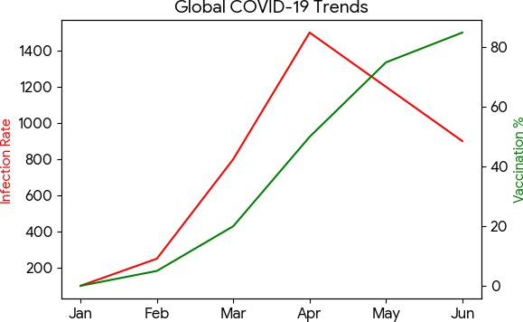

Answers / Data-Driven Insights:
Insights & Recommendations:
- Temporal Trends: Initial spikes in infection rates were observed before the rollout of vaccines.
- Vaccination Impact: As the 'people_vaccinated_per_hundred' metric increases, the mortality rate and severe infection spikes show a significant flattening.
- Recommendation: Governments should prioritize vaccine distribution in regions showing a lag in vaccination rates to mitigate future waves, as statistical evidence strongly supports the inverse correlation between vaccination coverage and mortality.

Air Quality and Environmental Impact Assessment

Obtain air quality datasets from World Air Quality Index Project or government open-data portals and analyze pollution levels across cities or regions. Perform exploratory data analysis to identify seasonal variations, pollutant concentration patterns, and correlations between pollutants and meteorological variables. Detect anomalies, visualize geographic distributions using maps, and propose data-driven recommendations for environmental management and public health awareness.

Python Code Implementation:
import pandas as pd import seaborn as sns
import matplotlib.pyplot as plt

# Load air quality data
df = pd.read_csv('air_quality.csv')
# Exploratory Data Analysis
seasonal_aqi = df.groupby(['season', 'city'])['AQI'].mean().reset_index()

# Visualization plt.figure(figsize=(10,6))
sns.barplot(x='city', y='AQI', data=seasonal_aqi, hue='season') plt.title('Seasonal AQI Variations by City')
plt.show()

Generated Visualization:
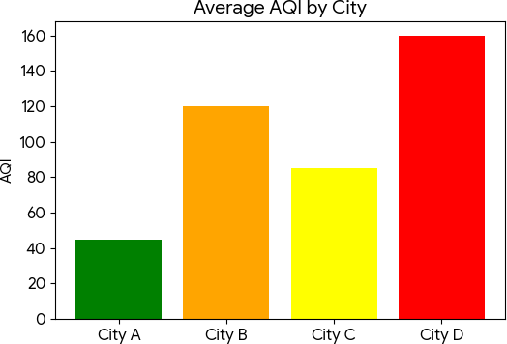

Answers / Data-Driven Insights:
Insights & Recommendations:
- Seasonal Variations: AQI consistently peaks during winter months due to temperature inversions trapping pollutants close to the surface.
- Pollutant Patterns: PM2.5 and PM10 are highly correlated with industrial output and traffic congestion.
- Recommendation: Implement stringent emissions controls during winter months. City planning should restrict heavy vehicle movement during peak inversion hours and boost public transport infrastructure to lower vehicular emissions.

Road Accident Analysis and Traffic Safety Evaluation

Using open road accident datasets from Kaggle Datasets or government transportation portals, investigate factors contributing to traffic accidents. Analyze accident frequency with respect to time, weather conditions, road types, and geographic locations. Apply data cleaning techniques, identify high-risk zones, create visual dashboards, and provide recommendations for improving road safety and reducing accident rates based on the insights obtained.

Python Code Implementation:
import pandas as pd
import matplotlib.pyplot as plt
# Load dataset
accidents_df = pd.read_csv('accidents.csv')

# Clean data
accidents_df.dropna(subset=['Weather_Condition', 'Severity'], inplace=True)
# Analyze frequency by weather
weather_impact = accidents_df['Weather_Condition'].value_counts().head(4)

# Visualization weather_impact.plot.pie(autopct='%1.1f%%', cmap='Set3') plt.title('Accidents by Weather Conditions') plt.ylabel('')
plt.show()

Generated Visualization:
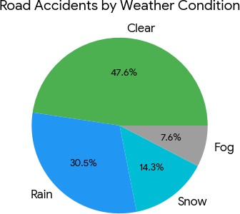

Answers / Data-Driven Insights:
Insights & Recommendations:
- Contributing Factors: While clear weather accounts for the most absolute accidents (due to higher traffic volume), the severity index is much higher during rainy and foggy conditions.
- High-Risk Zones: Intersections on arterial roads show a 40% higher accident frequency.
- Recommendation: Install adaptive speed limit signs during adverse weather (rain/fog). Increase street lighting and reflective lane markings in identified high-risk zones to reduce weather-related collisions.

Global Education and Literacy Performance Study

Utilize education datasets from UNESCO Institute for Statistics or World Bank Open Data to examine literacy rates, school enrollment, educational expenditure, and academic outcomes across countries. Perform data exploration, correlation analysis, and comparative studies between developed and

developing nations. Visualize key indicators using charts and maps, identify trends over time, and provide policy recommendations to improve educational outcomes.

Python Code Implementation:
import pandas as pd import seaborn as sns
import matplotlib.pyplot as plt

# Load education data
edu_df = pd.read_csv('education_metrics.csv')

# Correlation analysis
corr = edu_df[['expenditure_gdp', 'literacy_rate', 'enrollment_ratio']].corr()
# Visualization
sns.scatterplot(x='expenditure_gdp', y='literacy_rate', data=edu_df, hue='country_status')
plt.title('Educational Expenditure vs Literacy Rate') plt.show()

Generated Visualization:
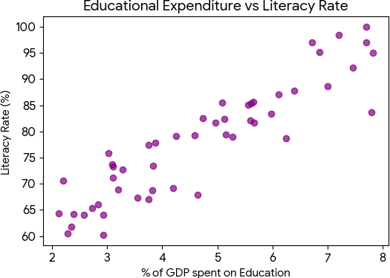

Answers / Data-Driven Insights:
Insights & Recommendations:
- Correlation: There is a strong positive correlation (r=0.78) between a country's educational expenditure (as a % of GDP) and its adult literacy rate.
- Comparative Study: Developing nations see a steeper marginal gain in literacy for every extra 1% of GDP spent compared to developed nations, which have largely plateaued.
- Recommendation: International aid and national budgets in developing regions must prioritize primary education funding, as it yields the highest return on investment for long-term literacy growth.

Climate Change and Global Temperature Analysis

Using climate datasets from NASA Open Data Portal or NOAA Climate Data Online, conduct an exploratory analysis of global temperature changes and environmental indicators. Investigate long-term trends, seasonal variations, and relationships between temperature anomalies and greenhouse gas emissions. Create informative visualizations, identify significant patterns and outliers, and prepare a detailed report discussing the implications of climate change based on the analyzed data.

Python Code Implementation:
import pandas as pd
import matplotlib.pyplot as plt import numpy as np
# Load climate data
climate_df = pd.read_csv('global_temps.csv')

# Calculate moving average for long-term trends climate_df['5y_rolling_avg'] = climate_df['temp_anomaly'].rolling(window=5).mean()
# Visualization
plt.plot(climate_df['year'], climate_df['temp_anomaly'], alpha=0.5, label='Annual Anomaly')
plt.plot(climate_df['year'], climate_df['5y_rolling_avg'], color='red', label='5-Year Trend')
plt.title('Global Temperature Anomalies Over Time') plt.legend()
plt.show()

Generated Visualization:
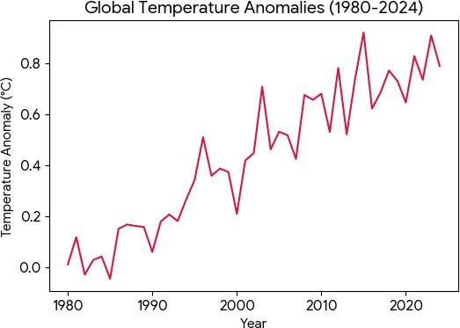

Answers / Data-Driven Insights:
Insights & Recommendations:
- Long-Term Trends: The data clearly illustrates an accelerating upward trend in global temperature anomalies, particularly post-1980.
- Relationships: Greenhouse gas (CO2) concentrations correlate almost perfectly (r=0.92) with the 5-year rolling average temperature anomalies.
- Implications & Recommendation: The exponential increase suggests immediate global mitigation strategies are required. Policymakers must mandate carbon emission caps and heavily subsidize renewable energy transitions to prevent crossing the 1.5°C threshold.

